**LIGHT EMMITING DIODE**

* LED consists of a chip of semi conducting material inundated, or doped, with impurities to create a p-n junction. As in other diodes, current flows easily from the p-side, or anode, to the n-side, or cathode, but not in the reverse direction. Charge carriers—electrons and holes—flow into the junction from electrodes with different voltages.
* When an electron meets a hole, it falls into a lower energy level, and releases energy in the form of a photon. The wavelength of the light emitted, and therefore its color, depends on the band gap energy of the materials forming the p-n junction.

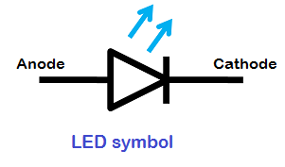

* In silicon or germanium diodes, the electrons and holes recombine by a non-radiative transition which produces no optical emission, because these are indirect band gap materials. The materials used for the LED have a direct band gap with energies corresponding to near-infrared, visible or near-ultraviolet light.
* LED development began with infrared and red devices made of gallium arsenide. Advances in materials science have made possible the fabrication of devices with ever-shorter wavelengths, producing light in a variety of colors.
* LEDs are usually built on an n-type substrate, with an electrode attached to the p-type layer deposited on its surface.
* Conventional LEDs are made from a variety of inorganic semiconductor materials, producing the following colors: (i) Aluminium gallium arsenide (AlGaAs) — red and infrared

(ii)Aluminium gallium phosphide (AlGaP) — green

(iii)Aluminium gallium indium phosphide (AlGaInP) — high-brightness orange-red, orange, yellow, and green

(iv)Gallium arsenide phosphide (GaAsP) — red, orange-red, orange, and yellow

(v) Gallium phosphide (GaP) — red, yellow and green

(vi) Gallium nitride (GaN) — green, pure green (or emerald green), and blue also white (if it has an AlGaN Quantum Barrier)

(vii) Indium gallium nitride (InGaN) — 450–470 nm — near ultraviolet, bluish-green and blue

(viii) Silicon carbide (SiC) as substrate — blue

(ix) Silicon (Si) as substrate — blue (under development)

(x) Sapphire (Al2O3) as substrate — blue (xi) Zinc selenide (ZnSe) — blue

(xii) Diamond (C) — ultraviolet

(xiii) Aluminium nitride (AlN), aluminium gallium nitride (AlGaN), aluminium gallium indium nitride (AlGaInN) — near to far ultraviolet (down to 210 nm)

**Advantages of Using LEDs**

* LEDs produce more light per watt than incandescent bulbs; this is useful in battery powered or energy-saving devices.
* LEDs can emit light of an intended color without the use of color filters that traditional lighting methods require. This is more efficient and can lower initial costs.
* The solid package of the LED can be designed to focus its light. Incandescent and fluorescent sources often require an external reflector to collect light and direct it in a usable manner.
* When used in applications where dimming is required, LEDs do not change their color tint as the current passing through them is lowered, unlike incandescent lamps, which turn yellow.
* LEDs are ideal for use in applications that are subject to frequent on-off cycling, unlike fluorescent lamps that burn out more quickly when cycled frequently, or HID lamps that require a long time before restarting.
* LEDs, being solid state components, are difficult to damage with external shock. Fluorescent and incandescent bulbs are easily broken if dropped on the ground.
* LEDs can have a relatively long useful life. One report estimates 35,000 to 50,000 hours of useful life, though time to complete failure may be longer .Fluorescent tubes typically are rated at about 30,000 hours, and incandescent light bulbs at 1,000–2,000 hours.
* LEDs mostly fail by dimming over time, rather than the abrupt burn-out of incandescent bulbs.

**Disadvantages of Using LEDs**

* LED performance largely depends on the ambient temperature of the operating environment. Over-driving the LED in high ambient temperatures may result in overheating of the LED package, eventually leading to device failure.
* LEDs must be supplied with the correct current. This can involve series resistors or current-regulated power supplies.
* Blue-light is hazardous for eye safety.

**APPLICATIONS OF LEDS**

LEDs are now widely used from house to laboratory, from industry to military, from lighting to entertainment and also from environmental cleaning to medical surgery. These are brilliant candidates for displays in mobile phones, laptops and high definition TVs.

**Working principle of LEDS**

**Light Emitting Diodes** are semiconductor devices that convert electrical energy into light energy.

## How Light Emitting Diode (LED) works?

* Light Emitting Diode (LED) works only in forward bias condition. When Light Emitting Diode (LED) is forward biased, the free electrons from n-side and the holes from p-side are pushed towards the junction.
* When free electrons reach the junction or depletion region, some of the free electrons recombine with the holes in the positive ions. We know that positive ions have less number of electrons than protons. Therefore, they are ready to accept electrons. Thus, free electrons recombine with holes in the depletion region. In the similar way, holes from p-side recombine with electrons in the depletion region.

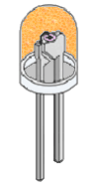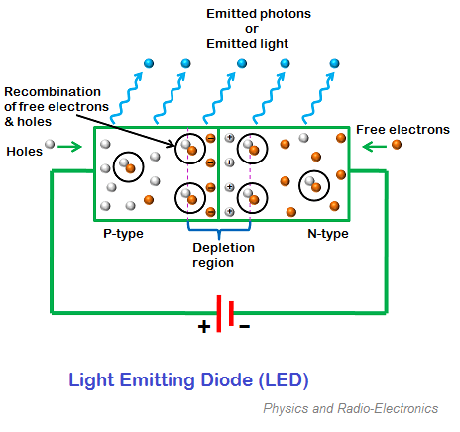

* Because of the recombination of free electrons and holes in the depletion region, the [**width of depletion region**](https://www.physics-and-radio-electronics.com/electronic-devices-and-circuits/semiconductor-diodes/widthofdepletionregion.html)decreases. As a result, more charge carriers will cross the [p-n junction](https://www.physics-and-radio-electronics.com/electronic-devices-and-circuits/semiconductor-diodes/p-n-junction-introduction.html).
* Some of the charge carriers from p-side and n-side will cross the p-n junction before they recombine in the depletion region. For example, some free electrons from n-type semiconductor cross the p-n junction and recombines with holes in p-type semiconductor. In the similar way, holes from p-type semiconductor cross the p-n junction and recombines with free electrons in the n-type semiconductor.
* Thus, recombination takes place in depletion region as well as in p-type and n-type semiconductor.
* The free electrons in the conduction band releases energy in the form of light before they recombine with holes in the valence band. In silicon and germanium diodes, most of the energy is released in the form of heat and emitted light is too small.
* However, in materials like gallium arsenide and gallium **phosphid**e the emitted photons have sufficient energy to produce intense visible light.

**LED Series Resistor Circuit**

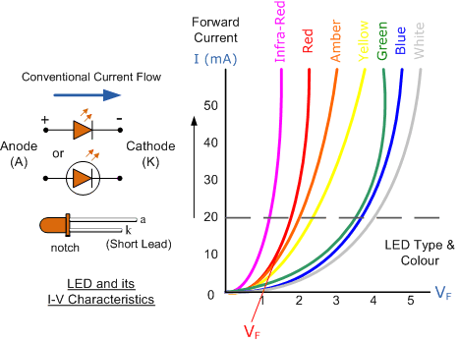

**LED Series Resistance.**

The series resistor value RS is calculated by simply using Ohm´s Law, by knowing the required forward current IF of the LED, the supply voltage VS across the combination and the expected forward voltage drop of the LED, VF at the required current level, the current limiting resistor is calculated as:

